**ASSIGNMENT – 3**

1. Define spreadsheet. What are the features of spreadsheet?

Ans: A spreadsheet is a computer program that can capture, display and manipulate data arranged in rows and columns. Spreadsheets are one of the most popular tools available with personal computers.

The following are just a few of the features available in most spreadsheet programs.

**Cell formatting**

Within the spreadsheet, selected cells can be formatted to represent various numeric values. For example, financial data can be given accounting formatting, which will apply [decimal](https://www.techtarget.com/whatis/definition/decimal) places and commas to represent dollars and cents.

**Formulas**

Under the formula bar, users can perform calculations on the contents of a cell against the contents of another cell. For example, if a person were using the spreadsheet to reconcile transactions, they could highlight all the cells that need to be added up and insert a sum function.

**Pivot tables**

Using a [pivot table](https://searchsqlserver.techtarget.com/definition/pivot-table), users can organize, group, total, average or sort data via the toolbar.

It's important to note that the exact tools and functions will vary depending on the application the user chooses.

1. Why is Excel also known as spreadsheet or worksheet?

Ans: The word "spreadsheet" came from "spread" in its sense of a newspaper or magazine item (text or graphics) that covers two facing pages, extending across the centerfold and treating the two pages as one large page.The compound word 'spread-sheet' came to mean the format used to present book-keeping ledgers—with columns for categories of expenditures across the top, invoices listed down the left margin, and the amount of each payment in the cell where its row and column intersect—which were, traditionally, a "spread" across facing pages of a bound ledger (book for keeping accounting records) or on oversized sheets of paper (termed 'analysis paper') ruled into rows and columns in that format and approximately twice as wide as ordinary paper.

1. Define cell, worksheet, and workbook. List operators according to the priority of operations.

Ans: A cell is the intersection between a row and a column on a spreadsheet that starts with cell A1. ... Each cell in a spreadsheet can contain any value that can be called using a relative cell reference or called upon using a formula.

A worksheet (also known as a spreadsheet) consists of cells in which you can enter and calculate data. The cells are organized into columns and rows. A worksheet is always stored in a workbook.

A workbook is a spreadsheet program file that you create in Excel. A workbook contains one or more worksheets.

| **Symbol 1** | **Type of operation** | **Associativity** |
| --- | --- | --- |
| **[ ] ( ) . -> ++ -- (postfix)** | **Expression** | **Left to right** |
| **Size of & * + - ~ ! ++ -- (prefix)** | **Unary** | **Right to left** |
| **typecasts** | **Unary** | **Right to left** |
| **\* / %** | **Multiplicative** | **Left to right** |
| **+ -** | **Additive** | **Left to right** |
| **<< >>** | **Bitwise shift** | **Left to right** |
| **< > <= >=** | **Relational** | **Left to right** |
| **== !=** | **Equality** | **Left to right** |
| **&** | **Bitwise-AND** | **Left to right** |
| **^** | **Bitwise-exclusive-OR** | **Left to right** |
| **|** | **Bitwise-inclusive-OR** | **Left to right** |
| **&&** | **Logical-AND** | **Left to right** |
| **||** | **Logical-OR** | **Left to right** |
| **? :** | **Conditional-expression** | **Right to left** |
| **= *= /= %= += -= <<= >>= &= ^= |=** | **Simple and compound assignment 2** | **Right to left** |
| **,** | **Sequential evaluation** | **Left to right** |

1. How excel can be used for data analysis and decision-making tools?

Ans: Analyze Data in Excel empowers you to understand your data through natural language queries that allow you to ask questions about your data **without** having to write complicated formulas. In addition, Analyze Data provides high-level visual summaries, trends, and patterns.

1. Define cell validation and conditional formatting. Explain cell reference and its types.

Ans: Data validation is a feature in Excel which is used to control what users can enter into a cell. It allows you to dictate specific rules. It also allows users to display a custom message if users try to enter invalid data.

Conditional formatting is a feature in Microsoft Excel that allows you to apply specific formatting to your cells according to certain criteria. It enables you to make sense of your data and spot significant trends.

There are two types of cell references: **relative** and **absolute**. Relative and absolute references behave differently when copied and filled to other cells. Relative references **change** when a formula is copied to another cell. Absolute references, on the other hand, remain **constant** no matter where they are copied.

### Relative references

By default, all cell references are **relative references**. When copied across multiple cells, they change based on the relative position of rows and columns. For example, if you copy the formula **=A1+B1** from row 1 to row 2, the formula will become **=A2+B2**. Relative references are especially convenient whenever you need to repeat the same calculation across multiple rows or columns.

#### 1.To create and copy a formula using relative references:

#### In the following example, we want to create a formula that will multiply each item's **price** by the **quantity**. Instead of creating a new formula for each row, we can create a single formula in cell **D4** and then copy it to the other rows. We'll use relative references so the formula calculates the total for each item correctly.

.

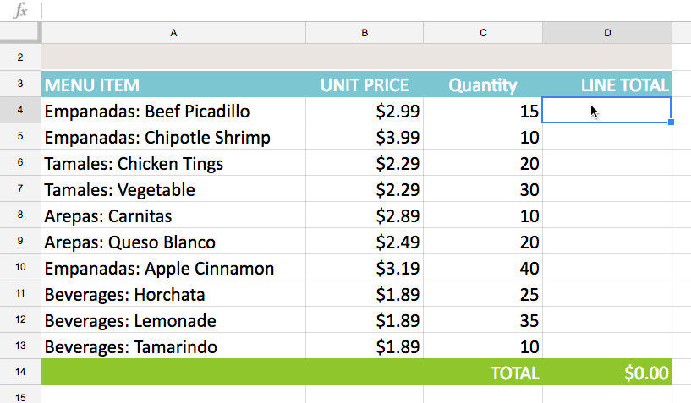

2.Enter the **formula** to calculate the desired value. In our example, we'll type**=B4*C4**.

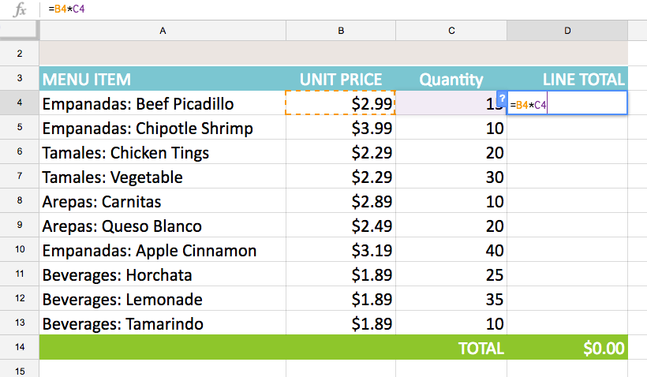

1. Press**Enter** on your keyboard. The formula will be calculated, and the result will be displayed in the cell.
2. Select the cell you want to copy. In our example, we'll select cell **D4**. The **fill handle** will appear in the bottom-right corner of the cell.

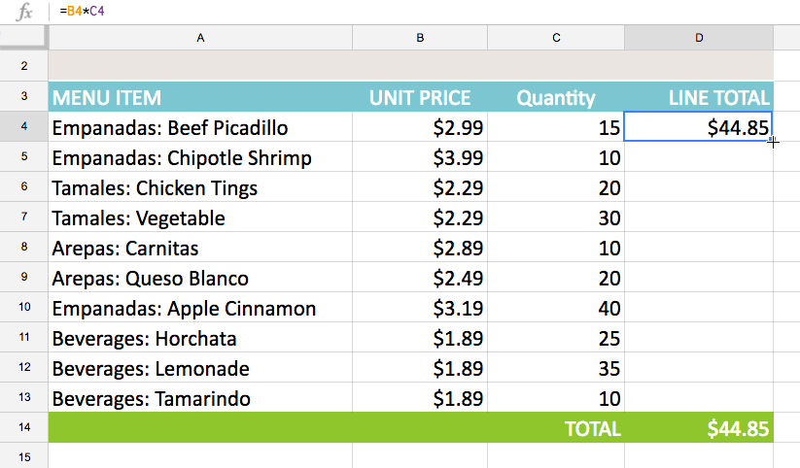

1. Click and drag the **fill handle** over the cells you want to fill. In our example, we'll select cells **D5:D13**.

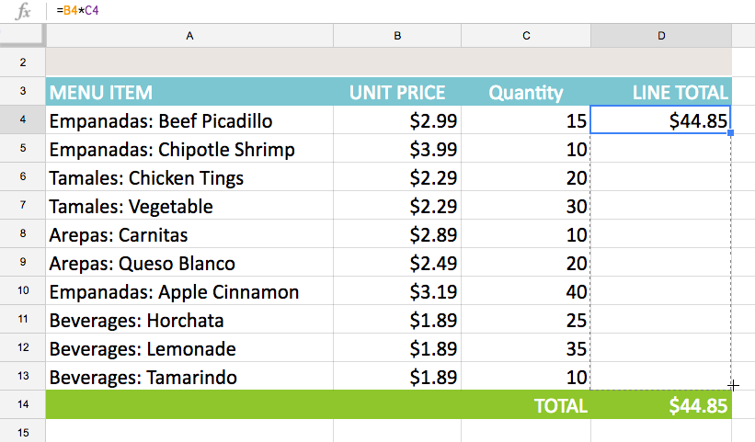

1. Release the mouse. The formula will be **copied** to the selected cells with**relative references**, displaying the result in each cell.

You can double-click the **filled cells** to check their formulas for accuracy. The relative cell references should be different for each cell, depending on their rows.

1. Absolute references

There may be times when you do not want a cell reference to change when copying or filling cells. You can use an **absolute reference** to keep a row and/or column constant in the formula.

An absolute reference is designated in the formula by the addition of a **dollar sign ($)**. It can precede the column reference, the row reference, or both.

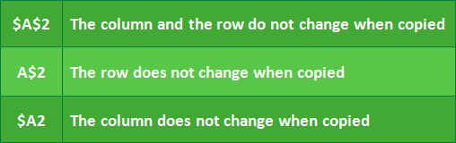

You will most likely use the **$A$2** format when creating formulas that contain absolute references. The other two formats are used much less often.

1. Select the **cell** that will contain the formula. In our example, we'll select cell**D4**.
2. Enter the **formula**to calculate the desired value. In our example, we'll type =**(B4*C4)*$E$2**, making **$E$2** an absolute reference.
3. Press **Enter**on your keyboard. The formula will calculate, and the result will display in the cell.
4. Select the cell you want to copy. In our example, we'll select cell **D4**. The **fill handle** will appear in the bottom-right corner of the cell.
5. Click and drag the **fill handle** over the cells you want to fill (cells **D5:D13** in our example).
6. Release the mouse. The formula will be **copied** to the selected cells with an**absolute** **reference**, and the values will be calculated in each cell.

6..Define pivot table and graphs. Write any five types of available chart in excel.

Ans: A PivotTable is an interactive way to quickly summarize large amounts of data. You can use a PivotTable to analyze numerical data in detail, and answer unanticipated questions about your data.

PivotCharts provide graphical representations of the data in their associated PivotTables. PivotCharts are also interactive.

Any five types of available chart in excel are as follows:

1. Column chart

2. Line chart

3. Bar chart

4. Area chart

5. Stock chart

6. Surface chart

7. Charts chart

8. Tree Map Chart.

1. Create a table with your own data and perform all the commands of What-If Analysis.

Ans: 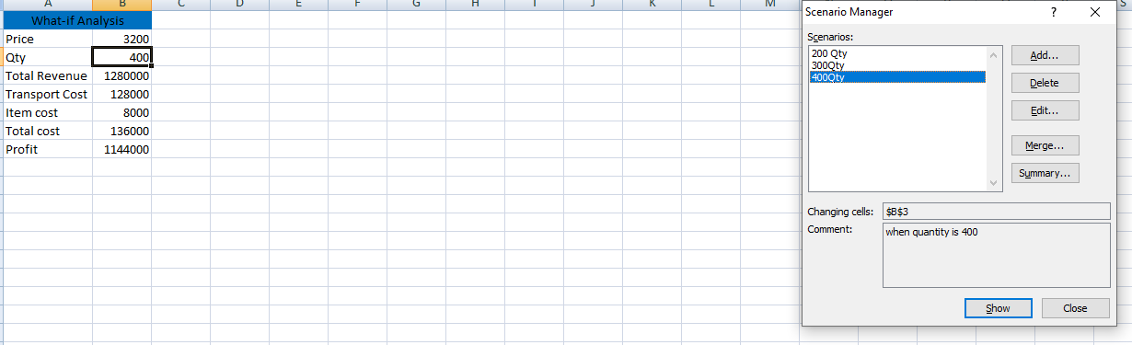

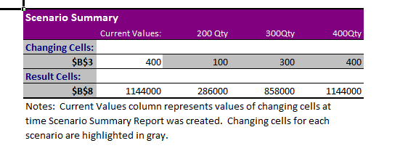

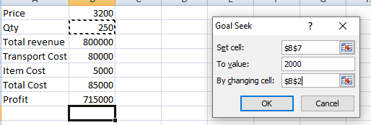

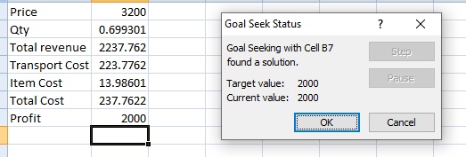

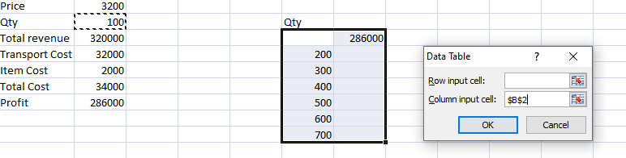

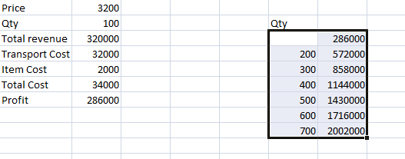

1. Create a table with your own data and analyze the data using pivot table.

Ans: 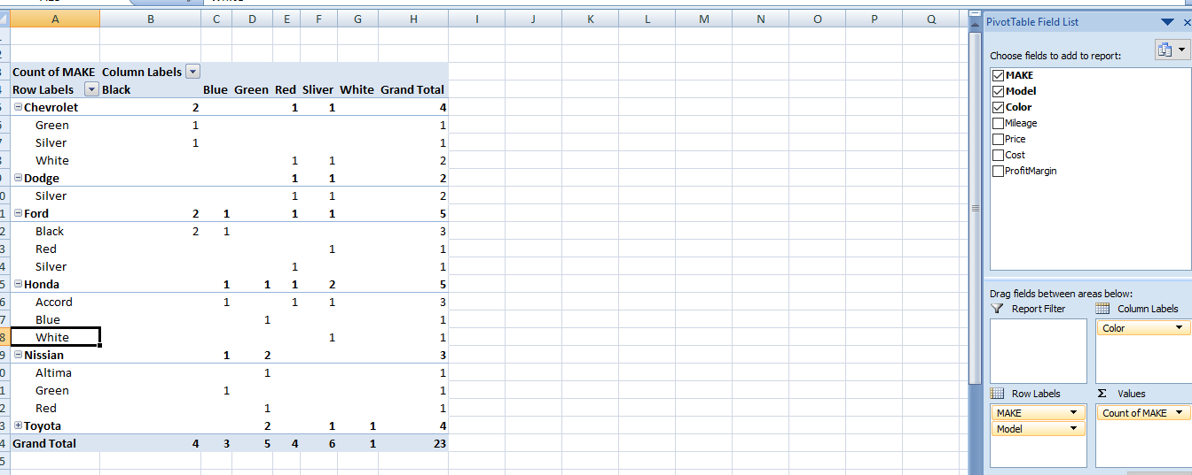

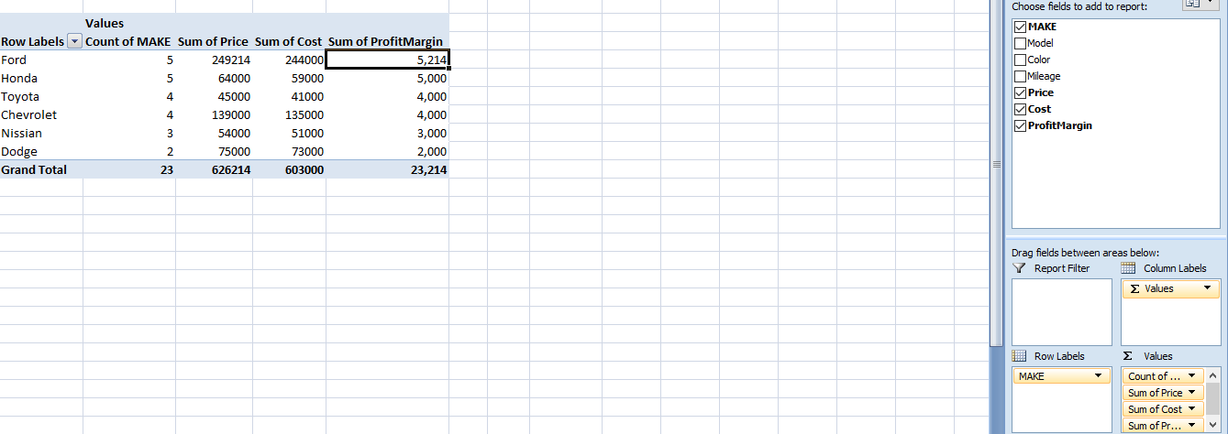

1. **Prepare a report on all the Tabs of MS Excel.**

# Ans: Ribbon and Tabs in Excel

**Excel ribbon** is the row of tabs and icons at the top of the Excel window that allows you to find, understand and use commands for completing a certain task. Excel ribbon is the primary interface that contains every command and feature. The Ribbon has multiple display options according to your preferences.

In Excel Ribbon, the buttons and icons are grouped into different tabs based on the category of their functionalities. It contains seven tabs: **Home, Insert, Page Layout, Formulas, Data, Review**, and **View**.

Each tab has its specific groups of related commands. These groups have several additional commands that can view by clicking the arrow at the right bottom corner of any group.

The Ribbon first appeared in Excel 2007, replacing the traditional toolbars and pull-down menus found in previous versions. In Excel 2010, Microsoft added the ability to personalize the Ribbon.

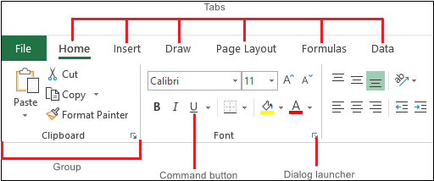

In Excel, the Ribbon is made up of these four basic components, such as:

1. **Ribbon tab:** It contains multiple commands logically subdivided into groups.
2. **Ribbon group:** A set of closely related commands normally performed as part of a larger task.
3. **Dialog launcher:** A small arrow in the lower-right corner of a group brings up more related commands. Dialog launchers appear in groups that contain more commands than available space.
4. **Command button:** It is the button you click to perform a particular action.

### Excel Ribbon Tabs

The standard Excel ribbon contains the following tabs, from left to right:

* **File:** It allows you to jump into the backstage view that contains the essential file-related commands and Excel options. This tab was introduced in Excel 2010 as replacing the Office button in Excel 2007 and the File menu in earlier versions.
* **Home:** It contains the most frequently used commands such as copying and pasting, sorting and filtering, formatting, etc.
* **Insert:** It is used for adding different objects in a worksheet such as images, charts, PivotTables, hyperlinks, special symbols, equations, headers, and footers.
* **Draw:** It depends on the device type you're using. It lets you draw with a digital pen, mouse, or finger. This tab is available in Excel 2013 and later, but the Developer tab is not visible by default.
* **Page Layout:** It provides tools to manage the worksheet appearance, both onscreen and printed. These tools control theme settings, gridlines, page margins, object aligning, and print area.
* **Formulas:** It contains tools for inserting functions, defining names, and controlling the calculation options.
* **Data:** It holds the commands for managing the worksheet data as well as connecting to external data.
* **Review:** It allows you to check spelling, track changes, add comments and notes, protect worksheets and workbooks.
* **View:** It provides commands for switching between worksheet views, freezing panes, viewing, and arranging multiple windows.
* **Help:** It only appears in Excel 2019 and Office 365. This tab provides quick access to the Help Task Pane and allows you to contact Microsoft support, send feedback, suggest a feature, and get quick access to training videos.
* **Developer:** It provides access to advanced features such as VBA macros, ActiveX and Form controls, and XML commands. This tab is hidden by default, and you have to enable it first.
* **Add-ins:** It appears when you open an older workbook or load an add-in that customizes the toolbars or menu.

### How to Hide Ribbon in Excel

If you want to use as much space as possible for your worksheet data, you can **minimize the Ribbon** by pressing the Ctrl + F1 shortcut key. It mostly happens when you are using a laptop with a small screen.

Or you can hide the Ribbon completely by clicking the **Ribbon Display Options** button at the upper-right corner of the Excel window and then select **Minimize the Ribbon**.

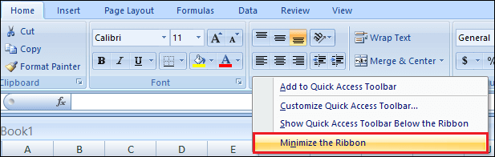

### How to Unhide Ribbon in Excel

If all commands disappeared from your Excel ribbon and only tab names are visible, then you need to press Ctrl + F1 to get everything back.

If the entire Ribbon is missing, then click the **Ribbon Display Options** button and unselect **Minimize the Ribbon**.

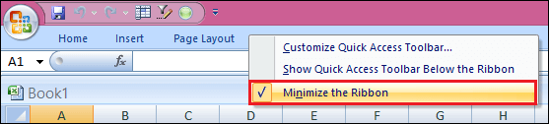

### How to Customize Excel Ribbon

If you want to personalize the Ribbon according to your requirements to know exactly where everything is located, you can easily access them.

You can enter the most customizations through the **Customize Ribbon** window under **Excel Options**. And the shortest path is:

* Right-click on the Ribbon,
* And select **Customize the Ribbon** button from the context menu,
* Then it shows you customize the excel options window.

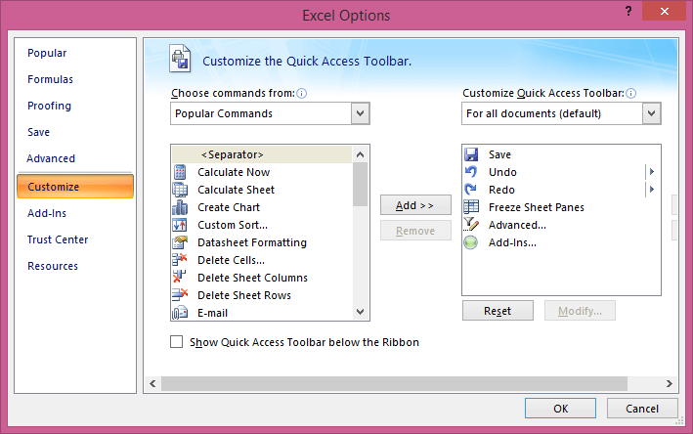

From there, you can add your tabs with any commands you choose, change the order of tabs and groups, show, hide, rename tabs, and a lot more.

### Contextual Ribbon Tabs

In addition to the constant tabs described above, the Excel ribbon also has context-sensitive tabs, aka **Tool Tabs**, which show up only when you select a certain item such as a **table, chart, shape**, or **picture**.

For example, if you select a chart, the **Design** and **Format** tabs will appear under **Chart Tools**.

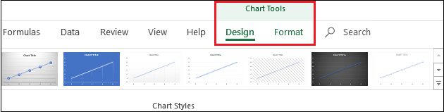

#### NOTE: If you are starting in Excel, Ribbon Hero might come in handy. It's a game created by Office Labs to help people explore the most useful features of the Office ribbon. Although this project is not actively developed or supported further, it is still available for download on the Microsoft website.

### How to Show Developer Tab

The Developer tab is a very useful addition to the Excel ribbon that allows you to access advanced features such as VBA macros, ActiveX and Form controls, XML commands, and more.

The problem is that the Developer tab is hidden by default. But it's very easy to enable it. Follow the following steps to enable this tab, such as:

* Right-click on the Ribbon,
* Click on the **Customize the Ribbon** tab,
* Select the **Developer**under Main Tabs, and click on the **OK**

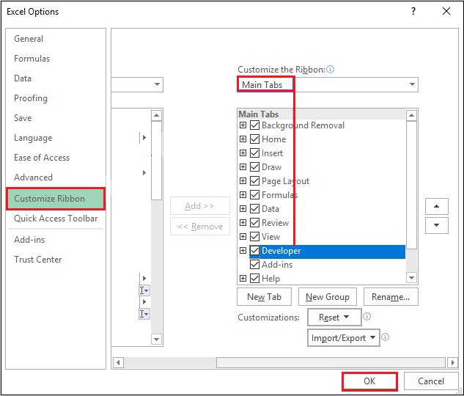

Similarly, you can activate other tabs available in Excel but not visible on the Ribbon, e.g., the **Draw** tab.

# Features of Tabs in Excel

The ribbon is designed to assist in quickly finding Excel commands to complete a task. The commands are grouped together in logical groups, which are collected together under tabs.

Each tab relates to a particular activity, such as page layout or view. Some tabs only appear when needed to reduce the clutter on the screen. These tabs are known as **Contextual** Tabs.

Commands related to working with Excel workbook content are represented as buttons on the tabs that make up the groups. The **Home** tab is activated by default when Excel is opened. Within each tab, except the **File** Tab, the buttons are organized into groups. In some groups, the button that might be used most often is larger than the other buttons.

Less common commands can be accessed by clicking the **Dialog Box** or **Task Pane Launcher** button located in the lower right corner of the group about the command.

Many tabs are available on the Ribbon in Microsoft Excel, such as Home, Insert, Page Layout, Formula, Data, Review, and View, and each tab has different features.

### Home Tab

The excel Home Tab is used to execute regular instructions like bold, underline, copy, and paste. It is also used to apply formats to cells in a worksheet. It contains Clipboard, Font, Alignment, Number, Cells, and Editing.

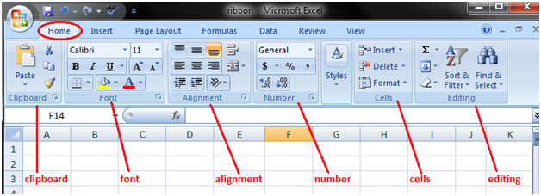

**1. Clipboard:** This Clipboard Group is primarily used for Cut copy and paste. It means, if you want to transfer data from one place to another, then you have two choices, either COPY (preserves the data in the original location) or CUT (deletes the data from the original location).

* There are options of **Paste Special**, which implies copy in the desired format.
* And there is also **Format Painter** Excel, which is used to copy the format from the original cell location to the destination cell location.

**2. Fonts:** This font group within the Home tab is used for choosing the desired Font and size. There are hundreds of fonts available in the dropdown, which we can use for.

In addition, you can change the font size from small to large, depending on your requirements. Also helpful is the feature of Bold (B), Italics (I), and Underline (U) of the fonts.

**3. Alignment:**This group is used to align tabs, such as Top, Middle, or Bottom alignment of text within the cell. And there are other standard alignment options like Left, middle, and right alignment. There is also an orientation option that can be used to place the text vertically or diagonally.

* **Merge and Center** is used to combine more than one cell and place its content in the middle. It is a great feature to use for table formatting etc.
* **Wrap text** can be used when there is a lot of content in the cell, making all the text visible.

**4. Number:** This group provides options for displaying number format. There are various formats available, such as general, accounting, percentage, comma style in excel, etc. You can also increase and decrease the decimals using this group.

**5. Styles:** You can have various styles for cells like Good, Bad, and Neutral. Other sets of styles are available for Data and Models like Calculation, Check, Warning, etc.

In addition, you can make use of different Titles and Heading options available within Styles.

* The **format Table** allows you to convert mundane data into an aesthetically pleasing data table quickly.
* **Conditional formatting** is used to format cells based on certain predefined conditions. These are very helpful in spotting the patterns across an excel sheet.

**6. Cells:** This group is used to modify the cell according to its height and width etc. Also, you can hide and protect the cell using Format Feature. You can also insert and delete new cells and rows from this group.

**7. Editing:** This group within the Home Tab is useful for Editing the data on an excel sheet. The most prominent of the commands here is the Find and Replace in Excel Also, you can use the sort feature to analyze your data (sort from A to Z or Z to A), or you can do a custom sort here.

### Insert Tab

The Insert Tab is used to insert distinct features like tables, pictures, clip art, shapes, charts, page numbers, word art, headers, and footers into a document. It contains Tables, Illustrations, Add-Ins, Charts, Tours, Sparklines, Filters, Links, Text, and Symbols groups. The below table describes each of the teams and buttons present on this tab.

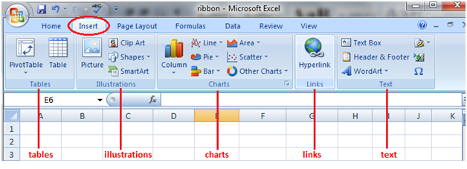

**1. Tables:** This group provides an excellent way to organize the data. You can use a table to sort, filter, and format the data within the sheet. You can also use Pivot Tables to analyze complex data very easily.

**2. Illustrations:** This group provides a way to insert pictures, shapes, or artwork into excel. You can insert the pictures directly from the computer or use Online Picture Option to search for relevant pictures.

* The **shapes** provide additional ready-made square, circle, arrow kinds of shapes that can use in excel.
* **SmartArt** provides an awesome graphical representation to visually communicate data in List, organizational charts, Venn diagrams, and process diagrams.

**3. Charts:** It helps you visualize the data in a graphical format. You can make graphs on your own, and excel provides various options like Pie-chart, Line Chart, Column Chart in Excel, Bubble Chart k in Excel, combo chart in excel, Radar Chart in Excel, and Pivot Charts in Excel. Recommended charts allow Excel to come up with the best possible graphical combination.

**4. Hyperlink:** This is a great tool to provide hyperlinks from the excel sheet to an external URL or files. Hyperlinks can also use to create a navigation structure with the excel sheet that is easy to use.

**5. Text:** This group is used to text in the desired format, such as add header and footer.

* **WordArt** allows you to use different styling for text.
* You can also create your signature using the **Signature line**
* **Symbols** are special characters that we may want to insert in the excel sheet for better representation.
* **The equation** allows you to write mathematical equations that we cannot ordinarily write in an Excel sheet.

### Page Layout Tab

The Page Layout Tab holds all the choices that permit you to rearrange your document pages simply in the manner you wish them. You can set margins, apply themes, manage page orientation and size, add sections and line breaks, show line numbers, and set paragraph indentation and lines. It contains Themes, Page Setup, Scale to fit, Sheet Options, Arrange.

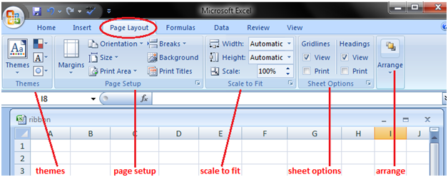

**1. Themes:** Themes allow you to change the style and visual look of excel. You can choose various styles available from the menu. You can also customize the colors, fonts, and effects in the excel workbook.

**2. Page Setup:** This is an important group primarily used along with printing an excel sheet.

* You can choose **margins** for the print.
* You can choose your printing **orientation** from Portrait to Landscape.
* You can choose the **size** of paper like A3, A4, Letterhead, etc.
* The **print area** allows you to see the print area within the excel sheet and helps make the necessary adjustments.
* We can also add a **break** where we want the next page to begin in the printed copy.
* Also, you can add a **background** to the worksheet to create a style.
* **Print Titles** is like a header and footer in excelthat we want them to be repeated on each printed copy of the excel sheet.

**3. Scale to Fit:** This option is used to stretch or shrink the printout of the page to a percentage of the original size. You can also shrink the width as well as height to fit in a certain number of pages.

**4. Sheet Options:** It is another useful feature for printing. If we want to print the grid, then we can check the print gridlines option. If we want to print the Row and column numbers in the excel sheet, we can also do the same using this feature.

**5. Arrange:** Here, we have different options for objects inserted in Excel like Bringforward, Send Backward, Selection Pane, Align, Group Objects, and Rotate.

### Formula Tab

The formula tab is used to insert functions, outline the name, produce the name, review the formula, etc. In the ribbon, the Formulas tab has vital and most helpful functions to form dynamic reports. It contains Function Library, Defined Names, Formula Auditing, and Calculation.

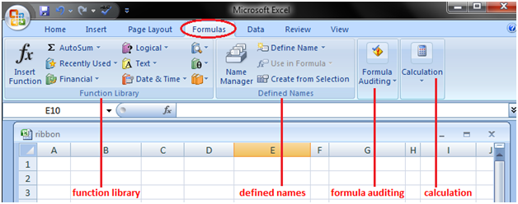

**1. Function Library:** This is a very useful group that contains all the formulas that one uses in excel. This group is subdivided into important functions like Financial Functions, Logical Functions, Date & Timing, Lookup & References, Maths and Trignometry, and other functions. One can also make use of Insert Function capabilities to insert the function in a cell.

**2. Defined Names:** This feature can be used to name the cell, and these named cells can be called from any part of the worksheet without working about its exact locations.

**3. Formula Auditing:** This is used for auditing the flow of formulas and their linkages.

* It can **trace the precedents** (origin of data set) and show which dataset depends on this.
* **Show formula** can also use to debug errors in the formula.
* The **Watch window** in excel is also useful for keeping a tab on their values as you update other formulas and datasets in the excel sheet.

**4. Calculations:** The option selected for calculation is automatic. However, one can also change this option to manual.

### Data Tab

The data tab contains options mainly for filtering, sorting, and manipulating data. It has options for importing external data.

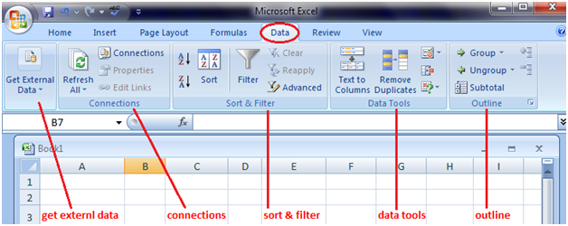

1. **Get External Data:** This option is used to import external data from various sources like Access, Web, Text, SQL Server, XML, etc.
2. **Power Query:** This is an advanced feature used to combine data from multiple sources and present it in the desired format.
3. **Connections:** This feature is used to refresh the excel sheet when the data in the current excel sheet comes from outside sources. You can also display the external links as well as edit those links from this feature.
4. **Sort & Filter:** This feature can be used to sort the data from A to Z or Z to A, and also you can filter the data using the dropdown menus. Also, one can choose advanced features to filter using complex criteria.
5. **Data Tools:** This is very useful for advanced excel users. One can create various scenario analyses using Whatif analysis - Data Tables, Goal Seek in Excel, and Scenario Manager. Also, one can convert Text to Column, remove duplicates and consolidate from this group.
6. **Forecast:** This Forecast function can be used to predict the values based on historical values.
7. **Outline:** One can easily present the data in an intuitive format using the Group and Ungroup options.

### Review Tab

The review tab contains tools mainly for spell checking, thesaurus, sharing, protecting, and tracking changes in Excel Worksheets.

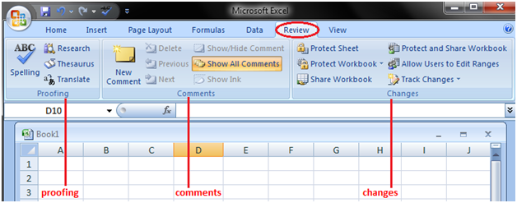

1. **Proofing:** Proofing allows you to run spell checks in excel. In addition to spell checks, one can also use a thesaurus if you find the right word. There is also a research button that helps you navigate the encyclopedia, dictionaries, etc., to perform tasks better.
2. **Language:** You can translate the excelsheet from English to any other language by using this feature.
3. **Comments: This feature is used** to write an additional note for important cells. It helps the user understand clearly the reasons behind your calculations etc.
4. **Changes:** If you want to keep track of the changes made, one can use the Track Changes option. Also, you can protect the worksheet or the workbook using a password from this option.

### View Tab

View tab contains mainly commands to view the Excel worksheet, like change views, freeze panes, arrange multiple windows, etc.

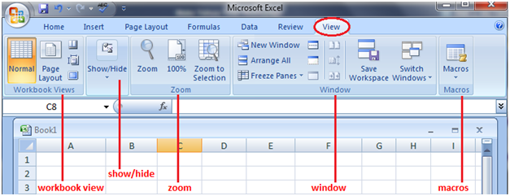

1. **Workbook Views:** You can choose the viewing option of the excel sheet from this group. You can view the excel sheet in the default normal view, or you can choose Page Break view, Page Layout view, or any other custom view of your choice.
2. **Show:** This feature can be used to show or not show Formula bars, grid lines, or Heading in the excel sheet.
3. **Zoom:** Sometimes, an excel sheet may contain a lot of data, and you may want to change zoom in or zoom out desired areas of the excel sheet.
4. **Window:** The new window is a helpful feature that allows the user to open the second window and work on both simultaneously. Also, freeze panesare another useful feature that allows freezing of particular rows and columns such that they are always visible even when one scrolls to the extreme positions. You can also split the worksheet into two parts for separate navigation.
5. **Macros:** This is again a fairly advanced feature, and you can use this feature to automate certain tasks in Excel Sheet. Macros are nothing but a recorder of actions taken in excel, and they can execute the same actions again if required.

# Quick Access Toolbar in Excel

The **Quick Access Toolbar** (QAT) is a small, customizable toolbar at the top of the Office application window that contains a set of frequently used commands. These commands can be accessed from almost any part of the application, independent of the ribbon tab that is currently opened.

The Quick Access Toolbar has a drop-down menu containing a predefined set of the default commands, which may be displayed or hidden. Additionally, it includes an option to add your own commands.

There is no limit to a maximum number of commands on the QAT, although not all the commands may be visible depending on the size of your screen.

### Where is the Quick Access Toolbar Located?

A customizable toolbar is located in the upper left corner of the Excel window, above the ribbon. If you want QAT to be closer to the worksheet area, you can move it below the ribbon.

When you click the down arrow at the end of the quick access toolbar, it displays more commands. You can add any of these commands to the quick access toolbar by a left click on the command.

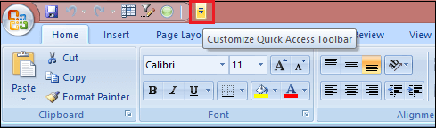

### Customized Quick Access Toolbar

By default, the Excel Quick Access Toolbar contains only three buttons: **Save, Undo,** and **Redo.** If you use a few other commands frequently, you can add them to the Quick Access Toolbar.

Microsoft provides many customization options for the QAT, but still, certain things cannot be done.

You can customize or free to personalize the Quick Access Toolbar with the following things, such as:

* Add your own commands.
* Change the order of commands, both default, and custom.
* Display the QAT in one of the two possible locations.
* Add macros to the Quick Access Toolbar.
* Export and import your customizations.

But here is a list of the following things that cannot be changed or cannot be customized, such as:

* You can only add commands to the Quick Access Toolbar. **Individual list items** (e.g., spacing values) and **individual styles** cannot be added. However, you can add the whole list or entire style gallery.
* Only command icons can be displayed, not **text labels.**
* You cannot **resize** the Quick Access Toolbar buttons. The only way to change the size of the buttons is to change your screen resolution.
* The Quick Access Toolbar cannot be displayed on **multiple lines.** If you've added more commands than the space available, some commands won't be visible. To view them, click the **More Controls** button.

### How to customize Quick Access Toolbar Window

Most customizations to the QAT are done in the Customize Quick Access Toolbar window, which is part of the **Excel Options** dialog box. You can open this window by following these steps:

**Step 1:** Click on the **File** tab and go to the **Excel Options.**

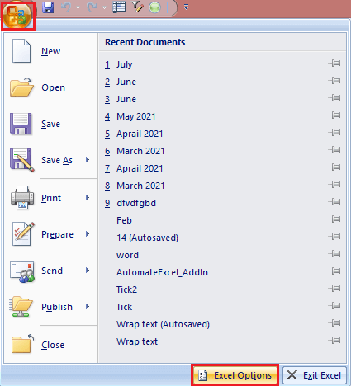

**Step 2:** Click on the customize button.

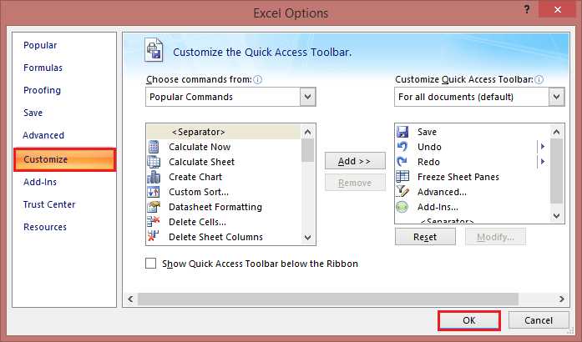

**Step 3:** The **Customize Quick Access** Toolbar dialog window will open, where you can add, remove, and reorder the QAT commands.

**Step 4:** And then click on the **OK** button.

### How to Add Command Button to Quick Access Toolbar

Depending on what kind of command you want to add, this can be done in three different ways.

1. **Enable a command from the predefined list**  
   To enable a currently hidden command from the predefined list, this is what you need to do:
   * Click the **Customize Quick Access Toolbar** button (the down arrow).
   * In the list of the displayed commands, click the one you want to enable.

For example, to be able to create a new worksheet with a mouse click, select the **New** command in the list, and the corresponding button will immediately appear in the Quick Access Toolbar:  
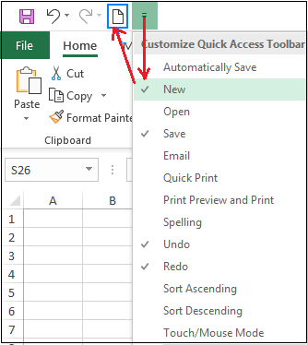

1. **Add a ribbon button to Quick Access Toolbar**  
   The fastest way to add to the QAT a command that appears on the ribbon is:
   * Right-click the desired command on the ribbon.
   * And select the **Add to Quick Access Toolbar** in the context menu.

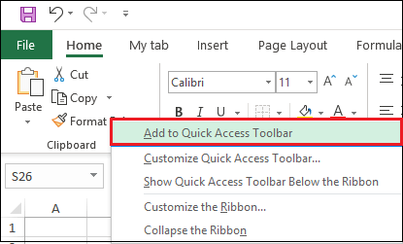

1. **Add a command that isn't on the ribbon to Quick Access Toolbar**  
   To add a button that is not available on the ribbon, follow these steps:  
   **Step 1:** Right-click on the ribbon and click **Customize Quick Access Toolbar.**  
   **Step 2:** In the **Choose commands from** the drop-down list on the left, select **Commands Not in the Ribbon.**  
   **Step 3:** In the list of commands on the left, click the command you want to add.  
   **Step 4:** Click on the **Add** button.  
   **Step 5:** Click on the **OK** to save the changes.

For example, to have **New** open Excel windows with a single mouse click, you can add the **New** button to the Quick Access Toolbar.

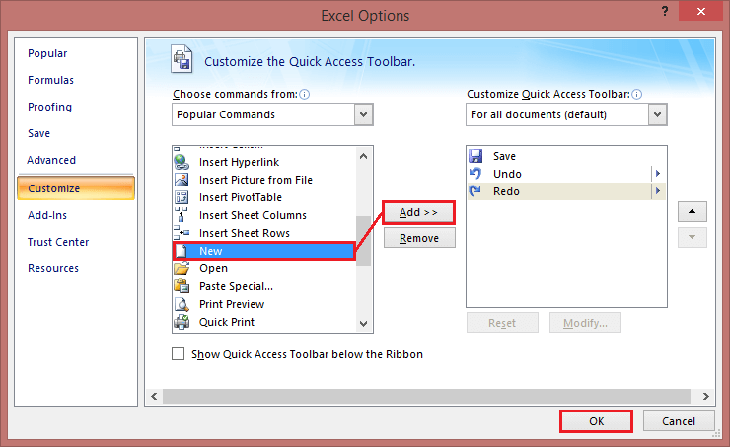

### How to Remove a Command from Quick Access Toolbar

To remove either a default or custom command from the Quick Access Toolbar, right-click it and pick **Remove from Quick Access Toolbar** from the pop-up menu.

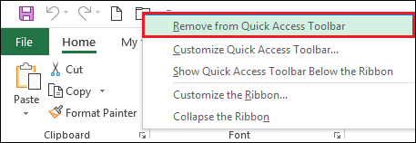

Or select the command in the **Customize the Quick Access Toolbar** window, and then click the **Remove** button.

### Rearrange Commands on Quick Access Toolbar

To change the order of the quick access toolbar commands, follow the following steps:

**Step 1:** Open the **Customize the Quick Access Toolbar** window.

**Step 2:** Under **Customize Quick Access Toolbar** on the right, select the command you want to move, and click the **Move Up or Move Down** arrow.

For example, to move the **New** File button to the far-right end of the quick access toolbar, select it and click the **Move Down** arrow.

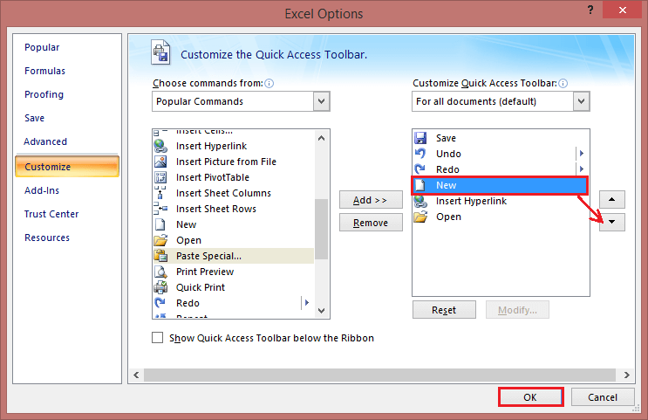

### Group Commands on Quick Access Toolbar

If your quick access toolbar contains quite a lot of commands, you may want to sub-divide them into logical groups. For example, separate the default and custom commands.

Though the Quick Access Toolbar does not allow creating groups like on the Excel ribbon, you can group commands by adding a separator. Follow the following steps, such as:

**Step 1:** Open the **Customize the Quick Access Toolbar** dialog window.

**Step 2:** In the **Choose commands from** the drop-down list on the left, pick **Popular Commands.**

**Step 3:** In the list of commands on the left, select and click **Add.**

**Step 4:** Click the **Move Up** or **Move Down** arrow to position the separator where needed.

**Step 5:** Click **OK** to save the changes.

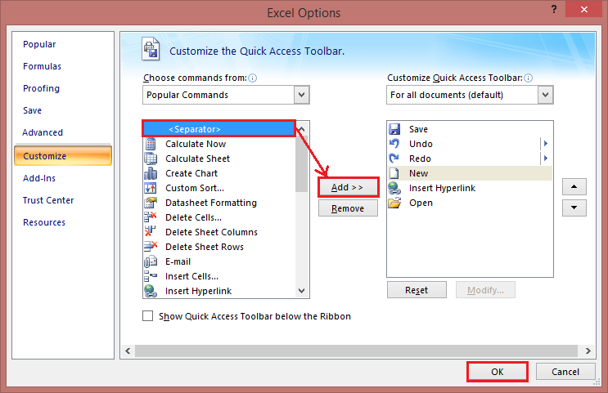

As a result, it separates the command, and the quick access toolbar appears to have two sections, as shown in the below image:

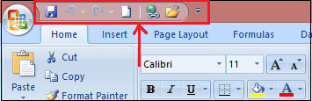

## Add Macros to Quick Access Toolbar

To have your favorite macros at your fingertips, you can add them to the QAT too. To have it done, then follow these steps:

**Step 1:** Open the **Customize the Quick Access Toolbar** window.

**Step 2:** In the **Choose commands from** the drop-down list on the left, select **Macros.**

**Step 3:** In the list of macros, select the one you wish to add to the Quick Access Toolbar.

**Step 4:** Click on the **Add** button.

**Step 5:** Click on the **OK** to save the changes and close the dialog box.

As an example, we are adding a custom macro **RANDOM** in the current workbook:

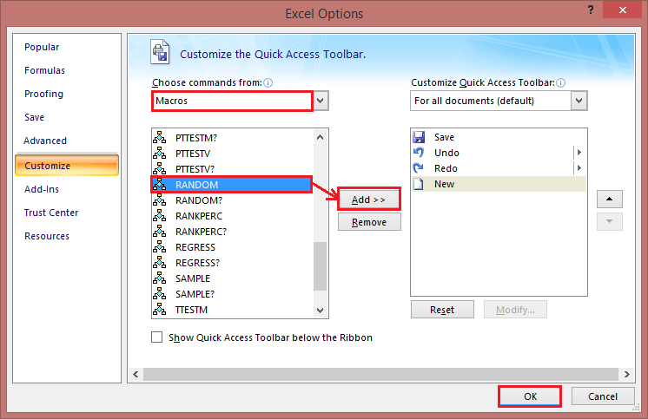

Optionally, you can put a separator before the macro like shown in the screenshot below:

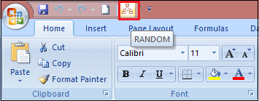

### Export and Import a Custom Quick Access Toolbar

Microsoft Excel allows saving your Quick Access Toolbar and ribbon customizations into a file that can be imported later. This can help you keep your Excel interface looking the same on all the computers you use and share your customizations with your colleagues.

1. **Export** a customized quick access toolbar:  
   In the Customize the Quick Access Toolbar window, click **Import/Export,** then click **Export all customizations,** and save the customizations file to some folder.
2. **Import** a customized quick access toolbar:  
   In the Customize the Quick Access Toolbar window, click **Import/Export,** select **Import customization file,** and browse for the customizations file you saved earlier.

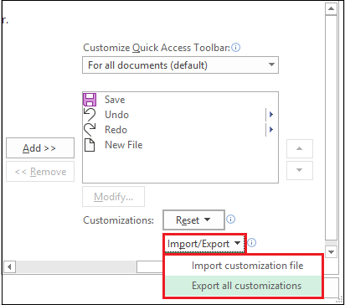

The file that you export and import also includes the **ribbon customizations.** Unfortunately, there is no easy way to export or import, only the Quick Access Toolbar.

When you import the customizations file to a given PC, all prior ribbon and **QAT** customizations on that PC are permanently lost. To restore your current customizations in the future, be sure to export them and save them as a backup copy before importing any new customizations.

# Mini Toolbar in Excel

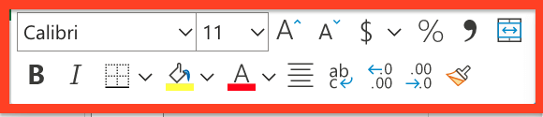

**The Mini Toolbar is a floating toolbar that appears above the shortcut menu when you right-click a cell or other objects like a shape or chart**. It is a small version of the full toolbar that displays commonly used formatting commands like **Bold, Italics, Font Size** and **Font Color**. The mini toolbar was introduced as a quick-access version so the Excel users can easily access the Font group, border, and few extra buttons on the Home tab.

The Mini Toolbar is also available in other office applications such as Word and PowerPoint. When you select any text or right-click on it, a faded, partially transparent pop window emerges on the top of your selected text. If you hover your mouse pointer over it, it immediately converts to its solid and usable form. Sometimes the Excel users may find it annoying as it keeps getting in the way. In that case, they can turn it off (we will learn the steps to turn off Mini Toolbar later in this tutorial).

**FACT:** Do you know that the Mini Toolbar feature is only available in the 2007 and 2010 versions of [Word](https://www.javatpoint.com/ms-word-tutorial), [Excel](https://www.javatpoint.com/excel-tutorial), [PowerPoint](https://www.javatpoint.com/powerpoint-tutorial), and [Outlook](https://www.javatpoint.com/outlook-app-for-android-mobile). The user can even turn off this feature if it is not required. However, the toolbar commands are pre-defined and cannot be customized to include different other functions.

### Mini Toolbar Mouse Pointer Rules:

* If you bring your mouse pointer towards the Mini Toolbar, it freezes and immediately becomes active.
* If you take your mouse pointer away from the Mini Toolbar, it disappears.
* You will notice that the Mini Toolbar disappears if you press any key from your keyboard or scroll the wheel of your mouse.

## Mini Toolbar Features:

The mini toolbar contains the most commonly used tools of the Home Tab. The list of the tools are as follows:

**1. Font Type**(Drop-Down) - The Font feature shows the list of fonts available in Excel. The user can quickly select or change the font of the cell as per their choices.

**2. Font Size**(Drop-Down). With the help of Font Size, you can quickly adjust the size of the text.

**3. Increase Font Size**- This feature allows Excel users to quickly increase the font size of the selected cell to the next larger font size.

**4. Decrease Font Size**- This feature allows the Excel users to quickly decrease the font size of the selected cell to the previous smaller font size.

**5. Percent Style**- With the help of the Percent Style feature, you can incorporate the percent number format into the selected cells.

#### NOTE: The shortcut key to perform percent style in Excel is Ctrl + Shift + %.

**6. Comma Style**- With the help of the Percent Style feature, you can incorporate the comma style number format into the selected cells.

**7. Accounting Number Format**(Drop-Down)- The Accounting Number feature incorporates the '**default**' number format to the selected cells. The drop-down consists of the following commands:

* English (UK)
* English (US)
* Euro
* and More Accounting Formats.

**8. Merge & Center**(Drop-Down). The Merger & Centre feature concatenates the selected cells and puts the contents in a new cell in the centre position. The drop-down consists of the following commands:

* Merge & Center
* Merge Across
* Merge Cells and Unmerge Cells

The Merge Across is similar to the Merge and Center feature with a single difference that merges and centres the selected cells in the same row with no change in the alignment.

**9. Bold**- This feature toggles bold on the selected cell.

#### NOTE: The shortcut key to apply Bold in Excel is Ctrl + B.

**10. Italic**- This feature toggles italics on the selected cell.

#### NOTE: The shortcut key to apply Bold in Excel is Ctrl + I.

**11. Center**- This feature aligns the content of the selected cell in the center position.

**12. Fill Color**(Drop-Down)- The Fill Color feature is useful whenever the user want to quickly apply a color to the background of the selected cell. The drop-down consists of the following commands:

* Theme Colors
* Standard Colors
* No Fill and More Colors.

**13. Font Color** (Drop-Down). As the name suggests, the Font colour features allow the Excel user to quickly change the colour of the font of the selected cell. The Font Color drop-down incorporates the below give commands:

* Automatic
* Theme Colors
* Standard Colors and More Colors.

**14. Borders**(Drop-Down). The Borders enables the users to quickly apply a border of any length and thickness to the selected cells. The Borders drop-down incorporates the below give commands:

* Bottom
* Top
* Left
* Right
* No
* All
* Outside
* Thick Box
* Top and Bottom
* Draw Border
* Thick Bottom
* Top and Thick Bottom
* Erase Border
* Bottom Double
* Top and Double Bottom
* Draw Border Grid
* Line Color
* Line Style and More Borders.

**15. Increase Decimal**- As the name suggest, this features adds one decimal place from the selected cells.

**16. Decrease Decimal**- As the name suggests, Increase Decimal adds one decimal place from the selected cells.

**17. Format Painter**- This feature copies the formatting from any cell (or group of cells or range) enabling the user to paste the same formatting elsewhere.

### Removing the Mini Toolbar

Many times, while working on excel, the Mini Toolbar pops up very often, and therefore many users may find it annoying as it keeps getting in the way. Thus, Excel provides the option to switch off Mini Toolbar. Following are the steps to turn off the Mini Toolbar from Excel:

1. In your Excel application, **click on File > Options > General**.
2. You will see the check box in front of the Show Mini Toolbar. **Clear the selection**. (Refer to the below screenshot)  
   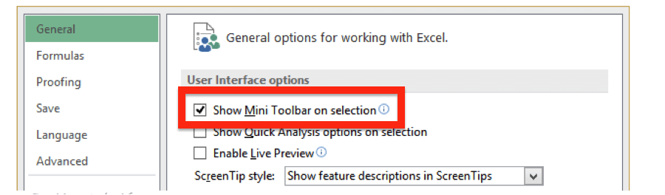
3. Click **OK**.

# Title Bar, Help Button, Zoom Control and View Buttons

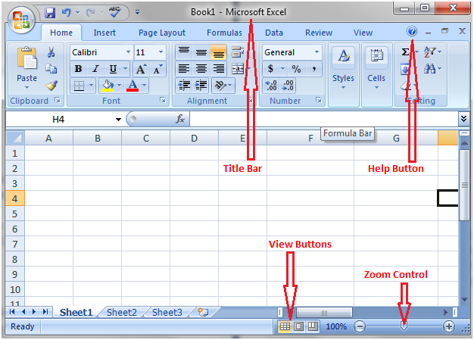

### Title Bar

It lies next to the quick access toolbar or on top of the excel window. It displays the name of the open document.

### Help Button

It lies on top right corner of the excel window beside the option to minimize the window. It is in the form of an encircled question mark. It provides excel related help.

### Zoom Control

Zoom control is a slider that lies next to view buttons at the right end of the status bar. It helps zoom in and zoom out the document. Move the slider to right or click on the plus sign to zoom in and move it to left or click on the minus sign to zoom out.

### View Buttons

There are three view buttons on the right end of the status bar, to the left of the zoom control. These buttons provide different options to view the document.

# Worksheets in Excel

While working with Excel, often you come across terms worksheet, Rows, Columns and Cells. In this tutorial we will briefly understand these terms along with their fundamentals and the operation (create, copy, paste, delete, etc) performed in them.

## Worksheet

A Worksheet is a single page **containing a collection of cells** where the user can store, update and manipulate the data. Worksheet is also called a spreadsheet. It is made up of **rows, columns and cells**.

#### NOTE: An Excel workbook can contain several worksheets.

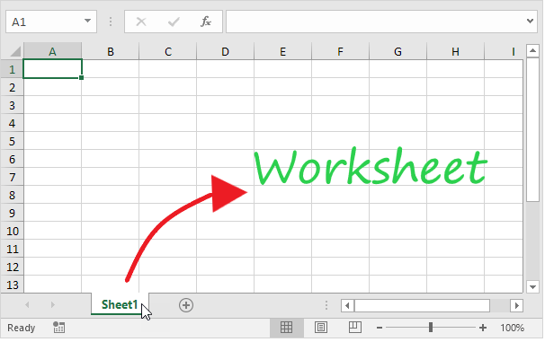

In Excel, individual data cells in a worksheet are defined and organized with the help of the vertical column and horizontal row that are combined to form a cell reference, unlike A1, B25, or R867.

The specifications for Excel Worksheet current versions include:

* Number of Rows per Worksheet: **1,048,576**
* Number of Rows per Worksheet: **16,384**
* Total cells per Worksheet: **17,179,869,184**

## Select a Worksheet

Whenever you open an **Excel** workbook, by default, Excel will take you to the Sheet1 worksheet. As you can see in the below image, the name of the worksheet 'Sheet1' is displayed on its sheet tab at the bottom of the windowpane. Though you can **rename it anytime**, we will cover the steps down in this tutorial.

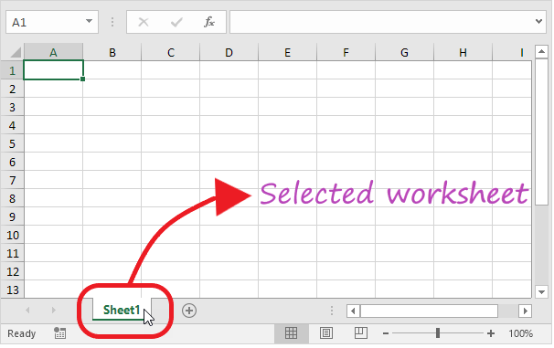

### Insert a Worksheet

Excel enables the user to insert multiple worksheets as per their requirement. To **insert a new worksheet** in excel, click on the plus (+) symbol located at the bottom of the windowpane. By default, the new worksheet will be named 'SheetN' where N represents an integer number 1,2,3,4,5,6,7,...., n.

In the below example, we have added a new worksheet named Sheet2.

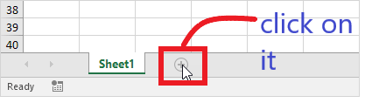

**Output**

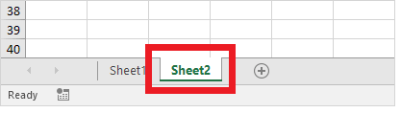

### Rename a Worksheet

To rename your worksheet with a customized and appropriate name following the below steps.

1. Right-click on the sheet tab for which you wish to change the name.
2. The toolbar window will appear. Choose the **Rename** option.  
   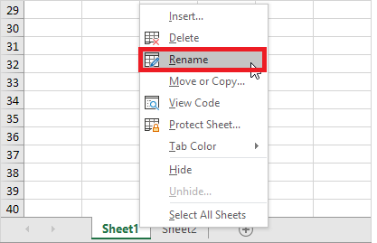
3. Type your preferred name. For instance, in the below screenshot, we have renamed 'Sheet1' to Sales 2021.  
   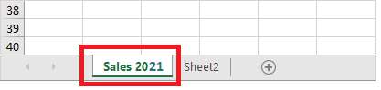

### Move a Worksheet

Excel allows the user to move and locate their worksheet in any order. Click on your worksheet sheet tab and **drag it to your preferred location**.

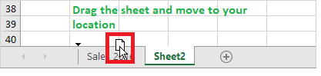

For instance, in the below example, we have dragged Sales 2021 before the 'Sheet 2' sheet tab.

**Output**

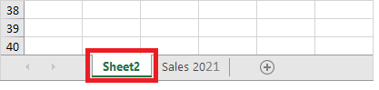

Delete a Worksheet

Deleting a worksheet in excel is very simple, follow the below steps:

1. Scroll down to the bottom and right click on a sheet tab.  
   
2. The dialog box will appear. Click on **delete**  
   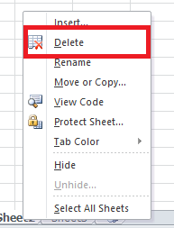
3. The sheet will be **immediately deleted**.

### Copy a Worksheet

While working many times, the Excel users require copying and pasting the data of one worksheet to another and making some changes. Excel provides easy steps to copy the data of one worksheet to another.

1. Right-click on the sheet tab that you want to copy.
2. The toolbar window will appear. Click on the 'Move or Copy' option.  
   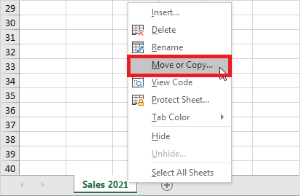
3. The 'Move or Copy' dialog box will be displayed. In the Before Sheet section, select the '**move to end'** option and make sure to check in the 'create a copy'.  
   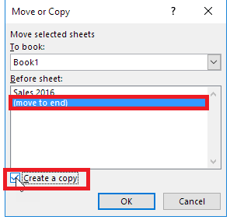
4. Click **OK**. Your data will be **copied** to the new worksheet.

## ROWS

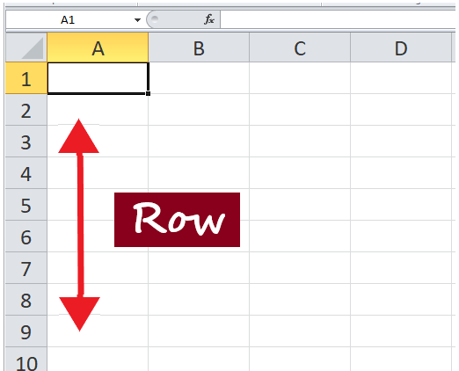

Rows run horizontally across the worksheet ranging from **1 to 1048576**. A row is **identified by the number on the left side** of the row, from where the row originates.

### Insert a Row in Excel

Many Excel users often need to insert a row in the worksheet to organize or manipulate their data.

1. Select and right-click on the cell within the row where you want to insert a new row.  
   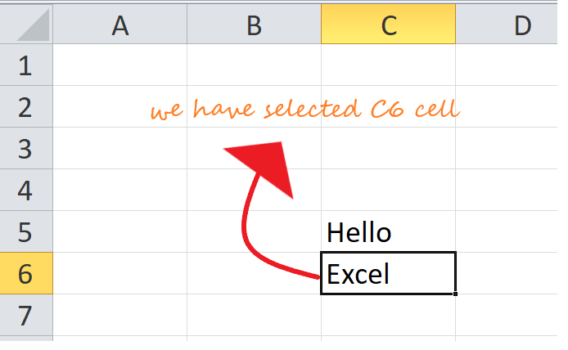
2. The dialog box will be displayed. Choose **Insert**.  
   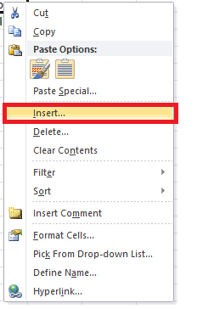
3. The insert dialog box will appear. Choose the '**Entire row'**  
   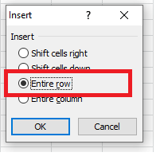
4. It will **insert a new row** at the top of your selected cell.  
   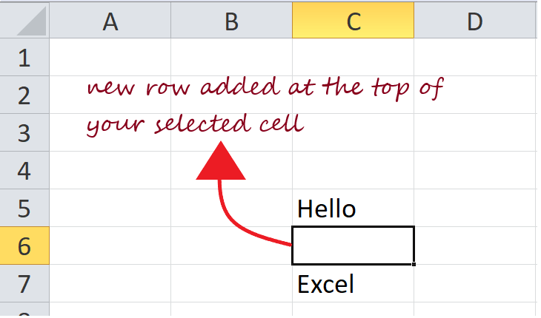

### Delete a Row in Excel

While working with Excel users need to delete a row in the worksheet to organize or manipulate their data. It's a lot easier to delete a row in excel.

1. **Select any cell** within the row that you need to **delete**. Right-click on the cell.  
   
2. The dialog box will be displayed. Choose **Delete**.  
   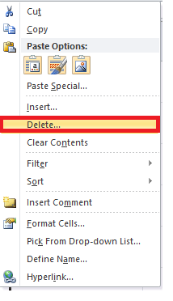
3. The **Delete** dialog box will appear. Choose the '**entire row**' option.  
   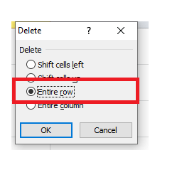
4. The entire row will be immediately deleted.  
   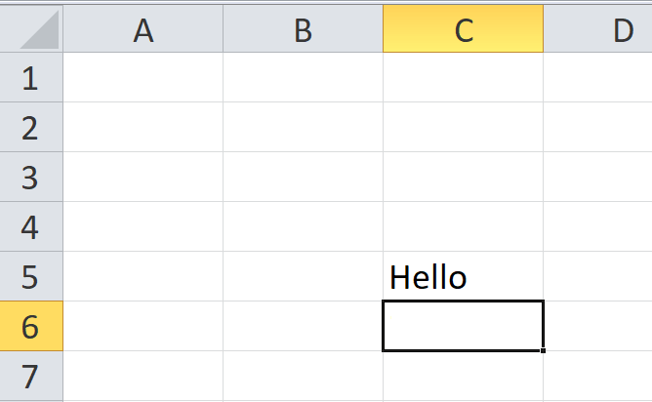

## COLUMNS

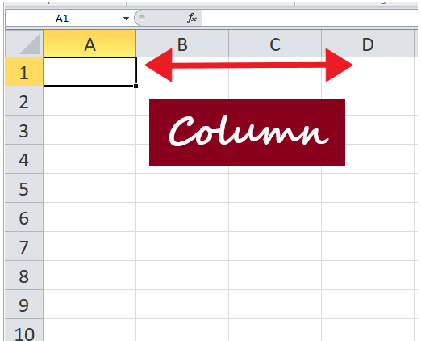

Columns run vertically downward across the worksheet ranging from **A to XFD (in total 16384 columns)**. A column is identified by a column header on the top of the column, from where the column originates.

### Insert a Column in Excel

Many Excel users often need to insert a column in the worksheet to organize or manipulate their data.

1. Select and right-click on the cell within the column where you want to **insert** a new column.  
   
2. The dialog box will be displayed. Choose **Insert**.  
   
3. The insert dialog box will appear. Choose the '**Entire column'**  
   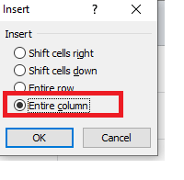
4. It will **insert a new column** at the left of your selected cell.  
   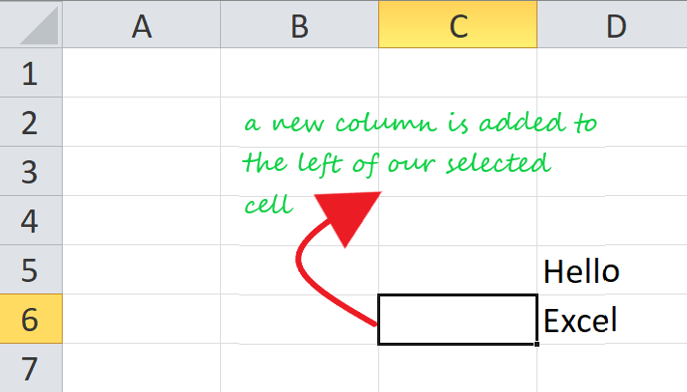

## CELLS

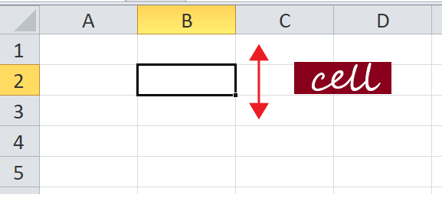

Cells are small **rectangular boxes in the worksheet where we enter data**. A cell is the intersection of a row and column. It is identified by row number and column header. In Excel, each cell is identified using a set of coordinates or positions, such as A1 (where A represents a column and 1 represents the row), B2, or M16.

You can perform several operations with cells in Excel, unlike changing the font style, font size, background color, text alignment, format painter, wrap text, and conditional formatting.

Excel provides the feature to select **multiple cells** at one time. A group of selected cells is collectively known as **cell range**. With cell range instead of a single cell address, the user refers to a cell range utilizing the cell addresses of the selected **first** and **last** cells, separated by a **colon**. For instance, a cell range covering B2, B3, B4, B5, B6, B7, B8, B9, and B10 would be addressed as **B1:B10**.

Cell Range: **B1: B10**

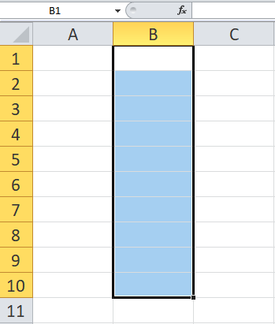

#### Now, as we have covered the basics, let's move towards the operation that could be applied to a cell.

### Select a cell

To perform any operation, i.e., to write, edit, delete, format, the user must first select a cell. Below given are the steps to select a cell in Excel:

1. With the help of your cursor, click on any cell.
2. Your cell is now selected, and you will notice a **rectangular border**around the same cell, and **the column and the row heading will be highlighted**.  
   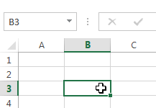
3. The **cell will remain selected**unless and until the user **points the cursor to another cell**.

### Select cell range

1. Click on the **first cell** from which to start the selection. **Hold and drag your cursor** to the last adjoining cells where you want to end the cell range.
2. Once done, **release the cursor**, and the desired cell range would be **selected**.  
   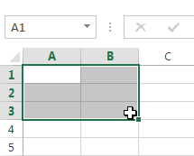
3. The cell will remain **selected**unless and until the user **points the cursor to another cell**.

### Cell content

Any data you enter in your Excel worksheet is stored in a cell. Each cell can hold various types of information, including string, numbers, formatting, formulas, and functions.

**1. String (Text)**

Cells can hold string values, unlike alphabets, numbers, and dates.

**2. Formatting properties**

Cells also include formatting properties that improve the appearance of your cell content. For instance, percentages can be displayed as 0.55 or 55%. You can make the cell content in Bold, Italics, change its font color, font size, or change its background color.

**3. Formulas and functions**

Cells can include predefined or customized formulas and functions that are helpful in calculations. For example, **SUM(A2:A5)** will add the number stored in each cell and give you the output.

### Insert content to a cell

1. Click and **select the cell**where you want to insert the content.  
   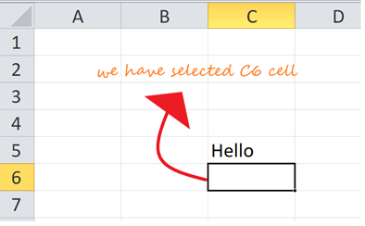
2. **Type in** the desired data into the selected cell, then **click the enter button or move your cursor to another cell**. The content will be shown in the cell and the formula bar.  
   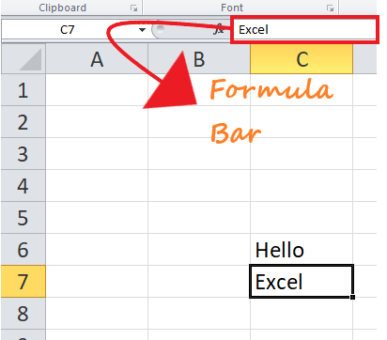

### Delete cell content

1. Click and **select** the cell.  
   
2. To delete the cell content, press the **Delete or Backspace key** from your keyboard.  
   
3. If you want to **delete multiple cells**, select the cell range and press the **Delete key**.  
   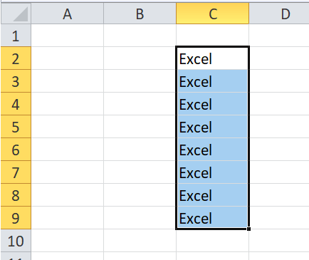

#### Note: Delete Key can delete the content of multiple cells at once, whereas the Backspace key only deletes the data of a single cell at a time.

### Delete cell(s)

People often get confused between deleting the cell content and deleting the cell itself, but there is a significant difference. If you delete the content, the cell will remain, and only the content gets omitted, whereas if you delete the cell, the cells below shift up or are shifted left and replace the deleted cell.

1. Click and select the cell(s).  
   
2. **Right-click** on the cell. The dialog box will be displayed. **Choose Delete**.  
   
3. The given below **Delete** dialog box will occur. Choose the 'entire row' option.  
   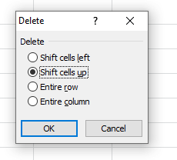
4. The cell will be immediately deleted and the cells lying below will **shift up**.  
   

## Drag and drop cells

Instead of copying and pasting the data, you can use the **drag and drop** option to move cell content from one cell to another.

1. Click and select the cell(s).
2. Point your cursor over the **border** of the selected cell(s) till it changes to a **black cross with four arrows**.Worksheet, Rows, Columns and Cells in Excel  
   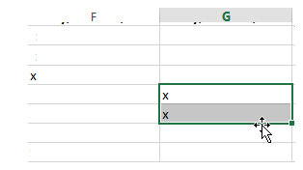
3. Drag your mouse cursor to the cell you prefer to paste the content. At this point the mouse pointer will change to a **dotted rectangle**.  
   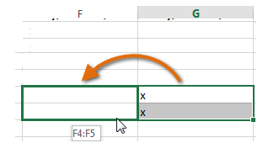
4. **Release the cursor**, and the content will be cut from the original cell and **pasted** in the selected location.  
   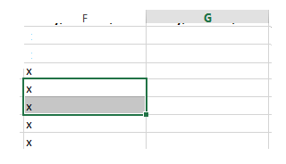
5. Perform the following.

1.Ans:Total: =SUM(B2:F2)

2.Ans: Average: =AVERAGE(B2:G2)

3.Ans: Percentage: =G2/H2*100

4.Ans: Level:

5.Ans: Rank: =RANK(I2,$I$2:$I$11)